|  |
| --- |
|  |
| Bipolar  Digital-to-Analog Converter  using  DAC0808 |
| INTEGRATED CIRCUITS LAB |
|  |
| |  | | --- | | **Project Report** | |  |   Sambhav R Jain - 107108103  Vangapandu Srivijay - 107108078  Kommanaboina Pramod - 107108060 |
|  |

|  |
| --- |
| The unipolar current output from a *DAC0808* is converted to a unipolar voltage using an op-amp in inverting mode. This is then processed into a bipolar voltage output after two stages of op-amps in difference amplifier mode. |

**TITLE:** ***BIPOLAR DIGITAL-to-ANALOG CONVERTER***

**OBJECTIVE:**

The aim of this project is to construct a bipolar DAC using *DAC0808* and verify its operation with the anticipated values.

**COMPONENTS USED:**

|  |  |  |  |
| --- | --- | --- | --- |
| Serial No. | Name | Type | Quantity |
| 1. | DAC0808 | 8-bit monolithic | 1 |
| 2. | Op-amp | IC741 | 3 |
| 3. | Resistor | 10kΩ | 11 |

**PRINCIPLE OF OPERATION:**

The *DAC0808* as such gives a current output equivalent to the digital input given to it. This current output is converted to a proportional voltage using a current-to-voltage converter (op-amp in inverting configuration). The analog output varies linearly from 0 to *V*ref depending on the digital input and the gain setting resistors (in our case, *R*f = *R*1). For an 8-bit DAC, output *V*o can be expressed as,

$$V_{o}=\frac{x}{2^{8}}×V_{ref}$$

‘*x*’ being the decimal equivalent of the digital input.

However, to get a bipolar voltage variation, the output *V*o should be of the form,

$$V_{o}=\frac{(2x-2^{8})}{2^{8}}×V_{ref}$$

|  |  |  |
| --- | --- | --- |
| Digital Input | *x* | *Vo* (bipolar) |
| 00000000 | 0 | $$-V_{ref}$$ |
| 01111111 | 127 | $$-\frac{1}{128}V_{ref}$$ |
| 10000000 | 128 | $$0$$ |
| 11111111 | 255 | $$+\frac{127}{128}V_{ref}$$ |

This way, if the MSB of the input is ‘0’, the output would be negative and if the MSB is ‘1’, the output would be positive.

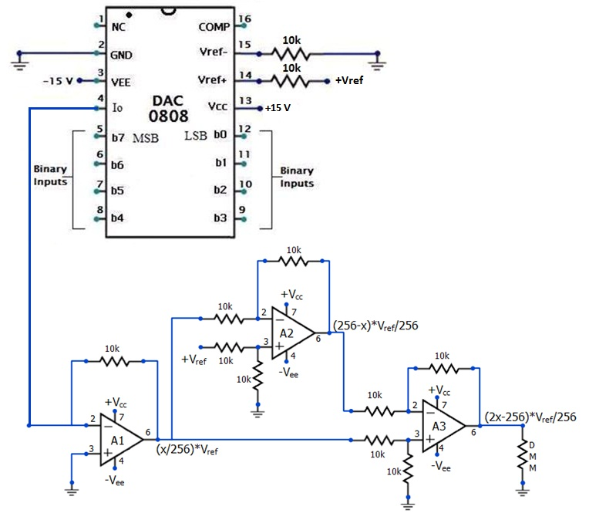**CIRCUIT DIAGRAM:**

All the resistors are selected to be equal, to have a unity gain at each stage.

+*V*cc = +15 V

+*V*ee = -15 V

+*V*ref = +5 V

-*V*ref is grounded

*x* = decimal equivalent of binary (digital) input

**CIRCUIT OPERATION:**

Let,

1. *V*A1 be the output voltage of A1
2. *V*A2 be the output voltage of A2
3. *V*A3 be the output voltage of A3

To get the complement of this, we use a difference amplifier A2 as shown in the circuit diagram. The resulting output voltage of A2 is

*V*A1 and *V*A2 are given to the next difference amplifier A3, such that

$V_{A3}=V_{A1}-V_{A2}$

$$V_{A3}=\frac{(2x-2^{8})}{2^{8}}×V_{ref}$$

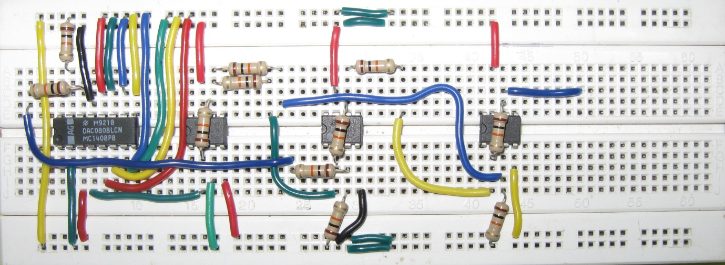

**SNAPSHOT:**

**OBSERVATIONS:**

|  |  |  |  |  |  |
| --- | --- | --- | --- | --- | --- |
| Digital Input | Binary Value (x) | VA1  (V) | VA2  (V) | VA3  (V) | Expected VA3 (V) |
| 00000000 | 0 | 0.7 $×{10}^{-3}$ | 4.938 | **- 4.947** | - 5.000 |
| 00000001 | 1 | 0.021 | 4.917 | **- 4.900** | - 4.961 |
| 00000011 | 3 | 0.061 | 4.877 | **- 4.820** | - 4.883 |
| 00000101 | 5 | 0.101 | 4.900 | **- 4.800** | - 4.805 |
| 00000111 | 7 | 0.139 | 4.800 | **- 4.666** | - 4.726 |
| 00001111 | 15 | 0.296 | 4.643 | **- 4.350** | - 4.414 |
| 00010101 | 21 | 0.420 | 4.589 | **- 4.170** | - 4.180 |
| 00011111 | 31 | 0.600 | 4.337 | **- 3.740** | - 3.789 |
| 00111111 | 63 | 1.196 | 3.740 | **- 2.550** | - 2.539 |
| 01010101 | 85 | 1.634 | 3.370 | **- 1.730** | - 1.680 |
| 01111111 | 127 | 2.350 | 2.600 | **- 0.225** | - 0.039 |
| 10000000 | 128 | 2.390 | 2.590 | **- 0.214** | 0 |
| 10000001 | 129 | 2.410 | 2.580 | **- 0.170** | 0.039 |
| 10000101 | 133 | 2.480 | 2.370 | **0.120** | 0.195 |
| 10010101 | 149 | 2.770 | 2.226 | **0.550** | 0.820 |
| 11000000 | 192 | 3.460 | 1.460 | **2.000** | 2.500 |
| 11010101 | 213 | 3.890 | 1.125 | **2.750** | 3.320 |
| 11100000 | 224 | 4.016 | 0.922 | **3.080** | 3.750 |
| 11110000 | 240 | 4.270 | 0.660 | **3.605** | 4.375 |
| 11111000 | 248 | 4.408 | 0.527 | **3.870** | 4.688 |
| 11111100 | 252 | 4.470 | 0.462 | **4.000** | 4.844 |
| 11111110 | 254 | 4.507 | 0.429 | **4.066** | 4.922 |
| 11111111 | 255 | 4.540 | 0.409 | **4.125** | 4.961 |

**TRANSFER CHARACTERISTIC:**

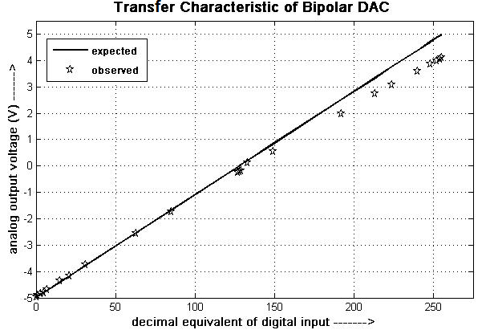

**INFERENCES & CONCLUSIONS:**

1. Using *DAC0808* as in the proposed circuit, bipolar operation is obtained and verified.
2. From the transfer characteristic it can be seen that the deviation of the observed output from the expected output is less for smaller values of digital input.
3. The maximum error in the analog output is for a digital input of 11111111.
4. The various causes of error may be:
   1. Presence of output offset voltage at the op-amps
   2. Actual resistance values may differ from the specified
   3. Non-linearity and gain error of the *DAC0808*